Flowchart vs. Pseudocode

[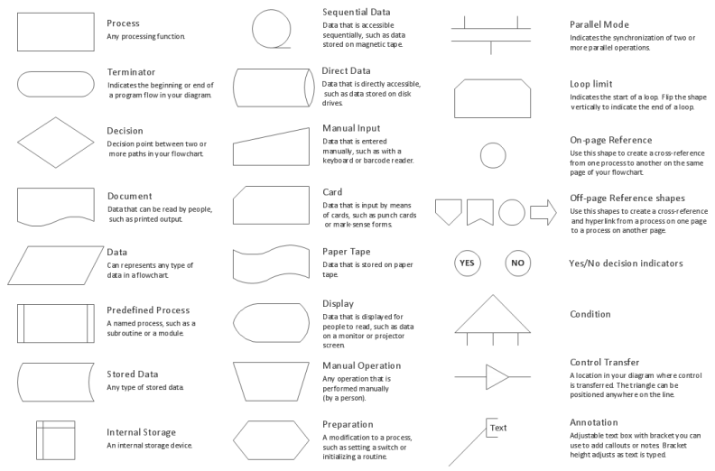](http://www.google.co.uk/url?sa=i&rct=j&q=&esrc=s&source=images&cd=&cad=rja&uact=8&ved=0ahUKEwjujf2_ieLPAhWKWRoKHdDyCLQQjRwIBw&url=http%3A%2F%2Fwww.conceptdraw.com%2FHow-To-Guide%2Fflowchart-symbols&psig=AFQjCNFYubqIeVDxVxpQOck_K0FlsWM4ag&ust=1476801776255011)A flowchart is a pictorial representation of how a program might work, i.e. the structure and processes of the program. It represents different instructions with different shapes such as:

As a result, the flowchart will resemble the program enough to be recognisable and will be easy to understand for most people as long as the definitions of the shapes are known. These can become quite complex if the program in question is complex or even just large and it can be quite hard to detail all the processes necessary when using flowcharts. However, pseudocode is much more reminiscent of actual coding as most of the structure seen in pseudocode will remain unchanged when using a programming language, and most of the time the only change seen between pseudocode and code is the vocabulary of the language.

[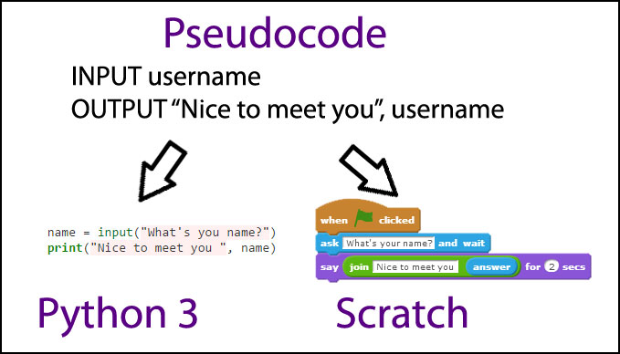](http://www.google.co.uk/url?sa=i&rct=j&q=&esrc=s&source=images&cd=&cad=rja&uact=8&ved=0ahUKEwjYhvKmiuLPAhXLChoKHZg_CIEQjRwIBw&url=http%3A%2F%2Fmr-west.uk%2Falgorithms%2Fpseudocode%2F&bvm=bv.135974163,d.ZGg&psig=AFQjCNFIn8oZ4jGKEC_Ka0em3JZCe3bgeQ&ust=1476801969938852)Pseudocode is a simple way of creating the structure and processes of the program in question without needing to pick a programming language and to learn that language as pseudocode can be easily translated into any programming language. Pseudocode can be written in plain English or with specific keywords or terminology which means it is very easy to use by anyone, unlike flowcharts which can be quite tricky to understand if you don’t know what a certain symbol means

|  |  |  |
| --- | --- | --- |
| **Structure** | **Pseudocode** | **Python** |
| Variable creation & initialisation | x AS INTEGER  x ← 0 | x = 0 |
| Assignment | x ← 4  assign 4 to x OR put 4 in x, | x = 4 |
| Arithmetic operations | y ← x * 7 | y = x * 7 |